Clean Bot Specification Document

Team: Amazon FTR 5
Members: Alvin Rogers, Nicasio Smith, Jaleel Williams



Table of contents
- Executive summary
- Purpose
- Overview
- Normative scope vs informative UI
- Repository map
- User stories
- Robot requirements
- Software and integration requirements
- Traceability
- System design
- Operational modes
- Runtime data flows
- Software architecture
- Dashboard component catalog
- Routing and information architecture
- State management
- External interfaces (API and WebSocket)
- Configuration and environment variables
- Resilience, errors, and security
- Robot-side software in this repository
- Technologies
- Additional features
- Database design
- User interface specification
- Test strategy, test plan, and CI
- Deployment
- Known limitations and follow-on work
- References
- Document history

1. Executive summary
The following summary provides a high-level view of the project's dual scope, clarifying the distinction between the physical robot hardware and the specific software deliverables implemented in this repository.
The Clean Bot field system is specified as a low-complexity robot: RGB camera trash detection, ultrasonic obstacle awareness, bearing-based approach to targets, and a small brush-roller intake (COLLECT-01, NAV-01).
The Terra Sweep Sparkle repository delivers the operator dashboard: a Vite/React/TypeScript SPA with REST + WebSocket integration, Zustand global state (with persistence), simulation and script-sync behaviors when no backend is reachable, Vitest and Playwright tests, and GitHub Actions for CI and optional Vercel deploy. A Flask (or equivalent) companion service on the robot or edge network is assumed by the HTTP paths and telemetry contract but is not implemented inside this repo.

2. Purpose
This chapter articulates the fundamental problem the Clean Bot aims to solve for users and defines the specific role of the operator dashboard in supervising the robotic system.
Small trash items (paper, plastic wrappers, lightweight debris) accumulate outdoors and are tedious to collect by hand. The Clean Bot is intended to detect those items, navigate toward them, and collect them with minimal human involvement.
The dashboard exists so an operator can supervise runs, issue start/stop, and observe battery, progress, and pose-aligned map feedback when telemetry is available—without requiring ROS CLI usage for routine demos or coursework.

3. Overview
Here, we summarize the system's capabilities across two distinct domains: the physical sensing and collection units on the robot, and the digital supervision features provided by the web dashboard.

3.1 Robot (design intent)
- Target navigation: Move toward detected trash using camera-guided bearing and distance control.
- Trash detection: RGB camera + object detection (e.g. TensorFlow Lite on device).
- Debris collection: Brush roller + small collection bin.
- Obstacle handling: Ultrasonic suite + avoidance logic while approaching targets.

3.2 Dashboard (this repository)
- Control: Deploy/stop (and script-sync start/stop when not in live telemetry mode).
- Status: Robot status, deploy state, battery, location string, cleaning progress, and optional normalized pose on the floor plan.
- Integration: fetch-based API client, typed robot service, WebSocket subscription to …/robot/updates.
- Quality: Error boundary, centralized error helper, exponential backoff retry on selected failures, ESLint + tests in CI.

4. User stories
We list here the core user stories that drove the development of both the hardware and software subsystems, providing the human context for every technical requirement.

Epic 1: Robot
- US 1.1: I want the robot to detect small trash items so that it only picks up waste and avoids non-debris objects.
- US 1.2: I want the robot to navigate toward detected trash items so that it can pick them up without my intervention.
- US 1.3: I want the robot to avoid bumping into obstacles so that it does not damage itself or objects in the area.
- US 1.4: I want the robot to successfully pick up trash items it approaches so that they are removed from the area.

Epic 2: Dashboard
- US 2.1: I want to see robot status, battery, location/progress, and (when available) pose on a map so I can trust what the robot is doing.
- US 2.2: I want to start and stop a run from the web UI so I do not depend on ROS commands for routine operation.
- US 2.3: I want clear feedback when the network or backend fails, and I want the UI to remain usable in a documented fallback mode.

5. Normative scope vs informative UI
The following section delineates strict system requirements from supplementary marketing or narrative content, ensuring that grading and verification efforts focus on the implemented system.
Content | Normative for traceability / grading | Notes
US 1.1–US 1.4 (robot) | Yes | Aligned with COLLECT-01 and NAV-01.
US 2.1–US 2.3 (dashboard) | Yes | Defined in §6.2 and §8.
Landing-page tabs (Home, Team, Problem, Project, multi-card “User Stories”) | Informative only | Marketing and course narrative; not additional system requirements unless your instructor explicitly widens scope.

6. Repository map
This detailed directory guide assists reviewers and developers in navigating the codebase, linking specific file paths to their functional roles within the application.
High-level layout (see also README.md):
Path | Role
src/App.tsx | Root layout: ErrorBoundary, React Query, router, toasters.
src/pages/Index.tsx | Single-page shell: Navigation + active section + Footer.
src/components/ | Presentational and composite UI (dashboard widgets, hero, etc.).
src/features/dashboard/ | Dashboard controller, task management, quick stats, robot simulation step.
src/services/robotService.ts | REST + WebSocket facade for robot API.
src/lib/api/client.ts | HTTP client (fetch), timeouts, interceptors, error normalization.
src/lib/config.ts, src/lib/constants.ts | Typed config and constants; env overrides.
src/lib/retry.ts, src/lib/errorHandler.ts | Backoff retry and user-facing errors.
src/store/ | Zustand robot store + TypeScript types.
src/hooks/ | Telemetry subscription, simulation tick, mission script sync.
tests/unit/, tests/integration/, tests/e2e/ | Vitest + Playwright.
.github/workflows/ | ci.yml (test + coverage + e2e), deploy.yml (Vercel optional).
scripts/robot/ | ROS 2 Python driver and mission JSON for sync demos.
public/missions/ | Mission JSON consumed by dashboard script mode.
docs/ | SECURITY.md, this specification.

7. Robot requirements
This section formalizes the minimum performance standards for the robot hardware, which are verified through physical testing and simulation rather than through this software repository.

- COLLECT-01: The robot must detect small trash items (paper, plastic wrappers, and other lightweight debris) using a camera-based vision system, navigate toward them, and collect them using the intake mechanism.
- NAV-01: The robot must navigate around obstacles to avoid moving and stationary barriers while approaching a detected trash item.

8. Software and integration requirements
The following specifications define the functional and non-functional requirements for the dashboard application, serving as the basis for automated testing and software verification.

- SR-QUAL: Code Quality & Type Safety
  - Description: Enforce strict TypeScript configuration with type-safe linting to catch errors at compile time and improve code reliability across the frontend codebase.
  - Maps to: US 2.3 (ensures UI reliability and prevents runtime failures that would break the fallback mode)
- SR-UI: User Interface & Error Handling
  - Description: Build a resilient web interface with error boundaries, fallback recovery mechanisms, async error handling, centralized logging, and environment-based API configuration to keep the UI usable even when the backend fails.
  - Fulfils: US 2.1, US 2.2, US 2.3 (core UI for robot control, start/stop commands, and fallback mode support)
- SR-CONFIG: Configuration Management
  - Description: Centralize robot configuration (constants, timing, thresholds, business rules) in a single module to enable easy updates and requirement-linked documentation.
  - Fulfils: US 2.1, US 2.2 (enables dynamic configuration of robot parameters and UI behavior)
- SR-TEST: Testing Framework
  - Description: Set up unit and integration testing infrastructure with Vitest or Jest configuration and test utilities.
  - Fulfils: US 2.3 (ensures code reliability through automated testing)
- SR-TRACE: Observability & Documentation
  - Description: Document React component architecture with TSDoc annotations, dependency mapping, and requirement traceability for maintainability.
  - Fulfils: US 2.3 (maintainable code = reliable fallback mode and easier debugging)

9. Traceability
The following matrices demonstrate how user stories and requirements are fulfilled by specific design components or code modules, ensuring full coverage of the project scope.

9.1 Robot subsystem
User story | Requirement source | System requirement | Design component
1.1 | Detect small trash; avoid non-debris. | COLLECT-01 | DC-S-01: Camera + object detection model
1.2 | Navigate to pickup range. | COLLECT-01 | DC-A-01: Target navigation (bearing + distance)
1.3 | Avoid obstacles while scanning/approaching. | NAV-01 | DC-S-02: Ultrasonic suite + DC-A-02: Obstacle avoidance
1.4 | Intake when in range. | COLLECT-01 | DC-M-01: Intake mechanism + bin

9.2 Dashboard subsystem

User Story | Requirement Source | System Requirement | Primary Implementation
2.1 | Operator visibility | SR-UI-02 | RobotStatusCard, BatteryIndicator, CleaningProgress, robotService
2.1 | Persisted session UI | SR-UI-03 | robotStore (Zustand), useRobotStore, src/store/robotStore.ts
2.1 | Configuration | SR-CONFIG-01 | src/lib/config.ts, constants.ts, timing/thresholds config
2.2 | Operator control | SR-UI-02 | robotService.deployRobot(), robotService.stopRobot(), DashboardSection
2.2 / 2.3 | Telemetry + failures | SR-UI-01 | ErrorBoundary, errorHandler.ts, retryWithBackoff, useRobotTelemetry
2.3 | Environment configuration | SR-UI-02.3 | getApiEnvironmentConfig(), environment variables
2.3 | Fallback mode | SR-UI-01 | ErrorBoundary, fallback UI rendering, simulation mode
2.1–2.3 | Quality & type safety | SR-QUAL-01 | tsconfig.json (strict mode), ESLint rules (TS-aware), src/components/**/*.tsx
2.1–2.3 | Component documentation | SR-TRACE-01 | TSDoc annotations, README notes, component dependency mapping
2.1–2.3 | Testing framework | SR-TEST-01 | vitest.config.ts, tests/unit/**, playwright.config.ts

10. System design
This architectural overview provides a logical map of the interactions between the browser-based UI, the backend API services, and the physical robot sensors.
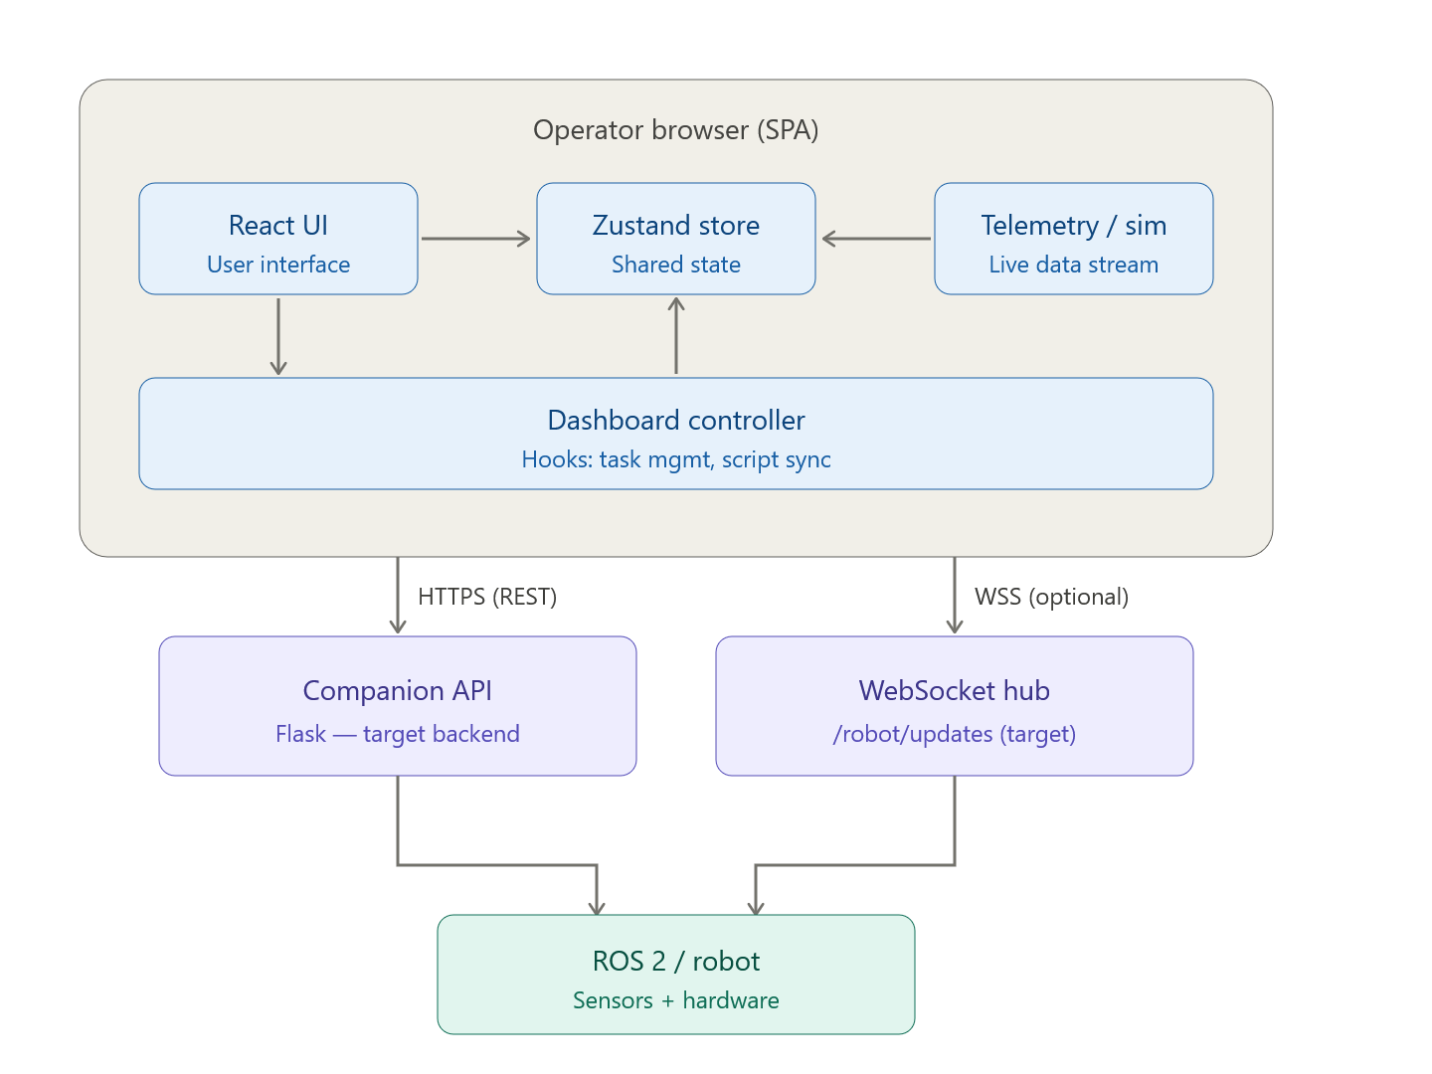

11. Operational modes
The table below explains the three distinct operational modes of the dashboard, detailing how the software adapts its behavior based on the availability of live telemetry.
telemetrySource (store) | Meaning | Control behavior highlights
live | Initial status fetch succeeded; WS may stream | Deploy/stop call robotService API paths.
simulation | Backend unreachable or explicit fallback | Deploy/stop still call API first; on failure, optimistic state + toast; battery/progress advanced by useRobotSimulation when status is cleaning.
script | Mission timeline driving UI (see script sync) | Deploy triggers startScriptMission instead of API when not live (useDashboardController).

12. Runtime data flows
We outline here the sequence of events for critical system operations, tracing data from user inputs or network triggers through the application's state management.

12.1 Application bootstrap
- main.tsx mounts App with ErrorBoundary.
- BrowserRouter loads Index at /.
- useDashboardController runs initialization hooks for telemetry and simulation.

12.2 Deploy (live)
- User clicks deploy; the controller initiates a request through robotService.
- Upon success, the store is updated with the new status, and the UI provides visual confirmation via toasts.
- Subsequent state refinements are streamed over the WebSocket.

12.3 Deploy (backend failure)
- If the API request fails, the catch block triggers a "simulation" fallback.
- The operator is notified of the connection issue, and the UI advances through an optimistic local state.

12.4 Telemetry stream
- The WebSocket listener parses incoming JSON packets from the robot companion service.
- Telemetry patches are merged into the Zustand store, updating live components like the floor plan map.

13. Software architecture
This chapter details the internal structure of the React application, defining the layering rules that ensure a clean separation between UI components, business logic, and I/O services.
Layers (top to bottom):
- Pages: High-level layout shells that coordinate different application sections.
- Feature hooks: Specialized logic for mission control, telemetry, and script synchronization.
- Services: The abstraction layer for all external communication (REST and WebSocket).
- Library: Shared utilities for error handling, retries, and centralized configuration.
- Store: The global state repository that serves as the single source of truth for all robot data.

14. Dashboard component catalog
The catalog below identifies each primary UI component and defines its specific responsibility within the operator dashboard.
Component / module | Responsibility
Navigation | Tab switching between the dashboard and informative site sections.
DashboardSection | The primary layout grid for robot monitoring and control.
RobotStatusCard | Visualizes the current machine state and location.
BatteryIndicator | Provides ring-style battery telemetry with status overlays.
DeployButton | Manages the mission lifecycle controls (Deploy/Stop).
CleaningProgress | Visualizes mission completion percentage.
FloorPlanMap | Overlays robot pose and status on a normalized map view.
SystemActivityLog | Generates a chronological log of robot events and warnings.
DashboardQuickStats | Summarizes high-level metrics (e.g., total debris collected).
ErrorBoundary | Provides a safety net for UI crashes with recovery options.

15. Routing and information architecture
This section defines the application's URL structure and the navigation hierarchy used to organize the project's technical and marketing content.
- Routes: Standard / for the main experience and a * wildcard for error handling.
- Primary IA: An SPA-style tab system allows seamless movement between the dashboard and project details.
- Dev server: Standardized local development and preview ports for consistency across environments.

16. State management
Here we specify the structure of the global store, the persistence strategy used for session continuity, and the rules for updating mission-critical data.
Store: useRobotStore in src/store/robotStore.ts.
Fields: Tracks deployment state, battery levels, cleaning progress, and spatial pose data.
Actions: Provides unified methods for status updates and telemetry merging.
Persistence: Utilizes localStorage to retain operator data across page refreshes, with specific "sanity checks" to prevent stuck UI states upon rehydration.

17. External interfaces (API and WebSocket)
This section serves as the definitive contract for all external communication, detailing the HTTP methods, paths, and payload formats required by the dashboard.
Base URL: Derived from environment-specific configuration.
Method | Path | Purpose
POST | /robot/deploy | Initiates the cleaning mission on the robot.
POST | /robot/stop | Halts the current mission and returns the robot to idle.
GET | /robot/status | Fetches a full snapshot of the robot's current state.
WebSocket URL: A persistent stream for high-frequency telemetry updates.

18. Configuration and environment variables
Application behavior is governed by environment variables that facilitate deployment across development and production environments.
Variable | Role
VITE_APP_ENV | development | staging | production
VITE_API_BASE_URL | REST base URL override
VITE_WS_URL | WebSocket origin override
VITE_STAGING_API_BASE_URL | Used when VITE_APP_ENV=staging if VITE_API_BASE_URL not set
VITE_STAGING_WS_URL | Same for staging WS
VITE_PRODUCTION_API_BASE_URL | Used when VITE_APP_ENV=production if VITE_API_BASE_URL not set
VITE_PRODUCTION_WS_URL | Same for production WS
VITE_DEPLOY_TIMEOUT_MS | UI / simulation deploy timing
VITE_RETURN_TIMEOUT_MS | Return timing
VITE_CLEANING_INTERVAL_MS | Simulation tick interval
VITE_BATTERY_LOW_THRESHOLD | Low-battery threshold (0–100)

19. Resilience, errors, and security
In this section, we describe the application's defense-in-depth strategies for handling network instability, rendering errors, and sensitive configuration data.
- Stability: Global Error Boundaries prevent localized crashes from breaking the entire session.
- Network: Timeouts and exponential backoff retries ensure robustness against transient API failures.
- Secrets: Strict environment variable patterns prevent the accidental exposure of backend credentials.

20. Robot-side software in this repository
Here we document the ROS 2 integration scripts and mission definitions included in the repository to support testing and coordinated hardware demonstrations.
- mission_sync_driver.py: Synchronizes physical robot movement with the dashboard's mission timeline.
- Mission Files: JSON definitions that allow the UI to drive simulated or scripted runs without a live perception stack.

21. Technologies
Robot Stack: ROS 2, Python, OpenCV, TensorFlow Lite, and Raspberry Pi hardware.
Dashboard Stack: React 18, TypeScript, Vite, Tailwind CSS, and Zustand for state management.

22. Additional features
- Simulation Engine: Advances battery and progress metrics when the robot is in a simulated cleaning state.
- Automation: Automated deployment workflows for optional cloud hosting.

23. Database design
This section clarifies the current status of the project's data persistence, distinguishing between the planned cloud database and the currently implemented local storage.
Planned Intent: Firebase Firestore for long-term session logs and multi-robot management.
Current Implementation: Browser-based localStorage via Zustand persistence for single-session UI state.

24. User interface specification

24.1 Canonical machine states
Defines the standard enum values for robotStatus (idle, cleaning, returning, etc.) and telemetrySource.

24.2 Feedback Mechanisms
Specifies the use of Sonner toasts for asynchronous command feedback and Recharts for telemetry visualization.

24.3 Visual Mockups
This section provides visual references for the implemented dashboard to aid in verification and operator onboarding.
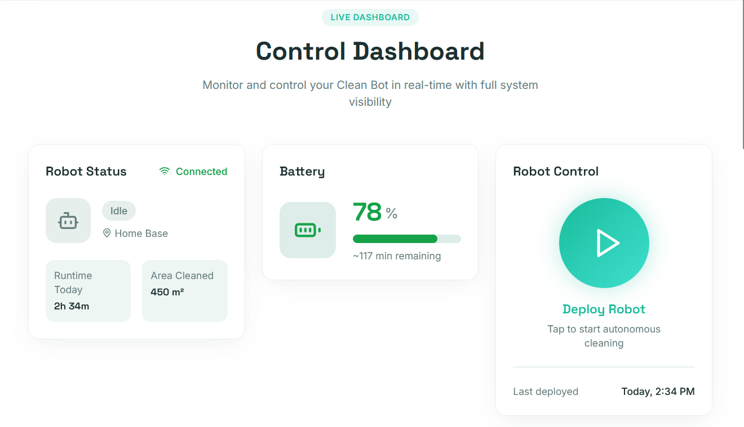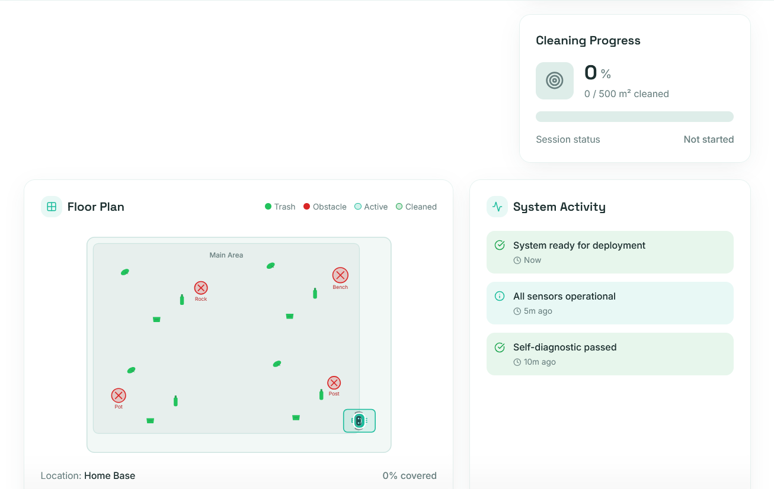

25. Test strategy, test plan, and CI

25.1 Robot track
Focuses on physical validation of camera accuracy, motor control, and obstacle avoidance maneuvers.

25.2 Dashboard track
Utilizes Vitest for logic and Playwright for browser-based end-to-end user journey verification.

26. Deployment
We document here the process for building and deploying the application, including the optional continuous delivery workflows integrated with GitHub Actions.
- Build Process: Uses Vite to produce optimized static assets for production use.
- Cloud Integration: Optional automation for deploying the dashboard to edge hosting providers.

27. Known limitations and follow-on work
This section provides a realistic assessment of the system's current boundaries, identifying unimplemented integrations and future technical debt to be addressed.
- External Dependencies: Clarifies that the Flask backend and AI perception models are managed outside this repository.
- Future Work: Identifies the wiring of Firestore for permanent session history as a high-priority next step.

28. References
- Traceability Matrix
- Project Repo

